Predicting Rocks and Mines using SONAR signals.
SONAR – Sound Navigation Ranging, is a technique for detecting and determining the distance and direction of underwater objects by acoustic means. Sound waves emitted by or reflected from the object are detected by sonar apparatus and analysed for the information they contain.
Problem Definition:
In this project, we are going to use the data received from the SONAR readings and classify if the object off which the SONAR signal bounced is a Mine or a Rock. Since we are classifying the records into either a Mine or a rock, we are dealing with a binary classification problem.
The dataset is available in the UCI repository. Click here to route to the repository. We will be using the “sonar.all-data” file from the repository.
Click here to view the code in the Github repository.
Dataset Information:
The file “sonar.all-data” contains 208 records that have 111 patterns obtained by bouncing sonar signals off a metal cylinder at various angles and under various conditions and 97 patterns obtained from rocks under similar conditions.
Features - Each record in the dataset is a set of 60 numbers ranging from 0 to 1, each representing the energy within a particular frequency band, integrated over a certain period of time.
Target Variable – There are two classes in the target variable. The letter "R" if the object is a rock and "M" if it is a mine (metal cylinder).
Loading the Data:
Data loading and manipulation is performed using Pandas library. Download the data from the UCI repository and save it as a .csv file. Load the data into a pandas data-frame using the pandas method read_csv(). Since the dataset does not have any header in the downloaded file, assign ‘None’ for the parameter ‘header’ in the read_csv() method. For code, visit Github
Data Analysis:
First let’s look at the number of records in the dataset using df.shape. There are 208 rows and 61 columns in the dataset. The data type of each column can be checked by using pandas’ .info() method. It shows that, the first 60 columns are of type ‘float64’, these are the independent variables and the 61st column is of type ‘object’ which is the dependent variable.
There are no null values in the dataset. The presence of null values can be detected using the df.isnull().sum().sum() method. This shows the number of null values (NaN – Not a Number) in each feature. The null values indicate the missing values in the dataset.
Descriptive statistics:
The statistical descriptive analysis of the data can be done using the describe() method. This gives a summary of all the descriptive statistics of all the numerical variables in the dataset. To see the descriptive statistics of all the numerical as well as the categorical variables, we need to set the “include" parameter as ‘all’ in the describe() method. For Categorical variables, it shows the count, the unique number of categories in the variable, top (category with highest frequency), the top category’s frequency. For the numerical variables it computes the mean, standard deviation, minimum value, the 25th percentile value, the 50 th percentile value, the 75 th percentile value and the maximum value. These statistics tells us if the distribution of the variable is normal or skewed, if there are outliers in the data, the quartile information and the unit scale information of the variables. For code and result, visit Github.
In our dataset, we have many skewed variables and the range of values for all the variables is 0 to 1. We can determine the skewness by looking at the mean and the median (50% quartile value). If the mean is greater than the median, the distribution is right skewed or positively skewed. If the mean is lesser than the median, then the distribution is left skewed or negatively skewed. It is important to understand the distribution because most of the machine learning algorithms assume that the distribution of the input variable is close to normal.
As many of our features are skewed, we may need some kind of a transformation method to make the distribution close to normal.
Checking if the target variable is balanced or not:
A categorical variable is balanced if the categories within the variable have almost same number of samples. We can check if the target variable is balanced or not by using value_counts() method
The following result indicates that we are dealing with a balanced target variable.
M 111
R 97
Name: 60, dtype: int64
Exploratory Data Analysis
A Closer look at the skewness and kurtosis:
Skewness of a distribution, tells us how far from the central tendency are the data points on the tails(right/left). The kurtosis is a statistical measure that defines how heavily the tails of a distribution differ from the tails of a normal distribution. In other words, kurtosis identifies whether the tails of a given distribution contain extreme values.
The general practice is to consider skewness value between -0.5 to +0.5 as close to normal. And anything outside this range would need a transformation however, the range purely depends on the domain and the problem itself. For this problem, I am considering +/-0.5. We can get the skewness and kurtosis of the variables using the code df.agg([‘skew’,’kurtosis’]). Alternatively, we can look at a visual plot that shows the skewness of the distribution. For code, visit Github
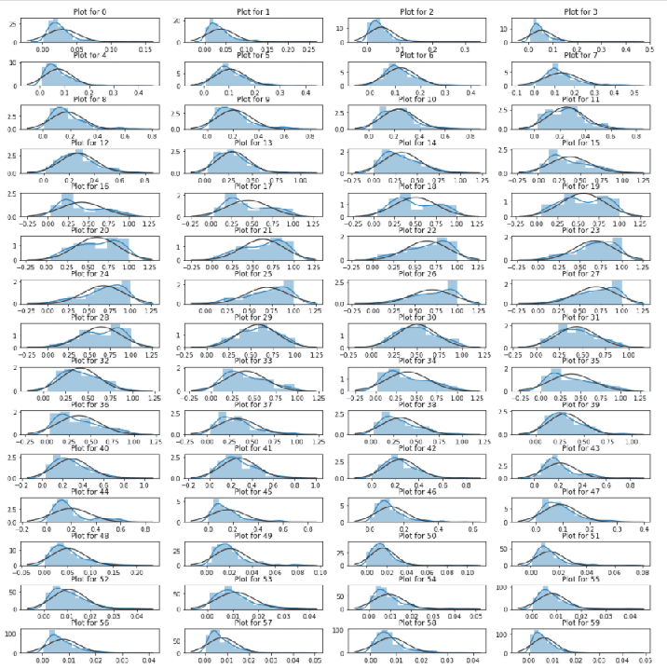
The above image shows the distribution of each variable in blue being compared with a normal distribution in black. In our dataset, most of the features are skewed. We will look at how to make the distributions close to normal in the pre-processing section of this blog.
Detecting Outliers in the dataset:
An outlier is an observation that lies at an abnormal distance from the other values in the sample. These can be much higher or lower than the other numbers. Outliers can adversely affect the model since these outliers can drastically change the mean of the sample however, have little effect on the median and the mode.
It is crucial to find the outliers and decide if these are really outliers or are just natural variations that are expected in the population. It is upto the analyst to decide that based on the problem and the domain. There are many ways to detect the outliers. In this project I am going to use the boxplot, z-score method and IQR.
Boxplots:
Boxplots can be used to visually look at the outliers. For code, visit Github
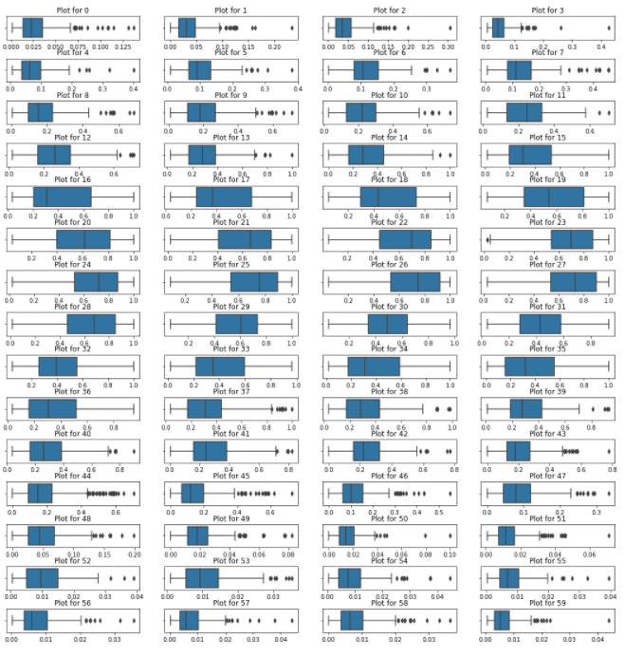
In the boxplot, the outliers are denoted as dots after/before the tails of the boxplot. From the above image it is evident that most of the features in the dataset have outliers. Lest look at the percentage of data that are outliers in the dataset.
Z-score method:
The z score is a measure of a data point, in terms of standard deviations from the mean. It shows us how many standard deviations away is a datapoint from the mean. The distribution is first converted into a standard normal distribution with mean 0 and standard deviation 1. According to the empirical rule, about 99.7% of the datapoints lie within 3 standard deviations of the mean. Hence it is a general practice to consider the data points beyond 3 standard deviations as outliers. Based on this, lets look at the percentage of data in our dataset that are outliers. To view the code for z score, visit Github
Results:
New df shape: (168,61), Old df shape: (208, 61)
Total loss of data is 19.23%

Wow!! 19.23% of the datapoints are considered as outliers by the z score. This is a lot of data to lose. We are ok it its 10% or less.
IQR method:
IQR is the inter-Quartile Range of a random variable. IQR is the distance between the 1st quartile (25% quantile) Q1 and the 3rd quartile (75% quantile) Q3.
IQR = Q3 – Q1
It is a general practice to consider (1.5 x IQR) – Q1 and (1.5 x IQR) + Q3 as the borders and any data points outside these as outliers.
To view code for IQR code, visit Github
Results:
New df shape: (134, 61), Old df shape: (208, 61)
Total loss of data is 35.57692307692308 %
IQR indicates that 35.6% of datapoints are outliers in our dataset.
As we have only 208 datapoint, to lose anything more than 10% of the data is going to adversely affect our model. Seeing these high percentage of outliers is making me incline towards thinking that these are more of a natural variation in the SONAR readings than outliers. Hence, I am going to experiment how the model performs with and without the outliers. And bases on the result I’ll decide whether to keep these outliers or remove them.
Now we have 3 datasets in hand.
- data -> with outliers
- new_data_z -> without outliers using z score
- new_data_iqr -> without outliers using IQR
Correlation:
Correlation is the measure that shows the extent to which the variables are linearly related to each other. The correlation could be positive or negative.
For correlation heatmap code, visit Github.
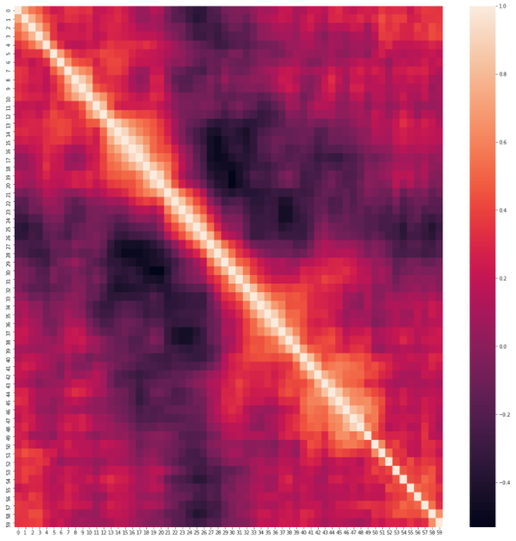
Notice that some of the variables have strong positive and negative correlations in the dataset with each other.
EDA Concluding Remarks:
- Most of the variables are skewed with greater than 0.5.
- The target classes seem to be balanced.
- Most of the variables are skewed and not normal distribution. There are left skewed and righted skewed distributions among the variables. We need to do some transformations to make the distributions more like Gaussian.
- Most of the variables have outliers. So, I will be experimenting with and without outliers to see how the model behaves in these two cases.
- Some of the variables are strongly correlated whether causal or not.
Pre-processing pipeline:
Encoding the target variable:
The target variables are ‘object’ type. Majority of the Machine Learning algorithms can understand only numerical data. Hence, I am encoding the target variable to convert it into a numeric variable. I assigned 0 for ‘R’(Rocks) and 1 for ‘M’(Mines). For code, visit Github
Feature Selection:
We will use all the features available in the dataset. For code, visit Github. I created 3 xs and ys. X and y contain dataset with outliers, x_z and y_z contains dataset without outliers using z score method and x_iqr and y_iqr contains dataset without using IQR method.
Experimenting Logistic Regression Model on the dataset with and without outliers:
I trained and tested a LogisticRegression model on the data with and without outliers. And the following is the result.
Result:
Test score without removing the outliers: 0.83
Test score after removing the outliers by z-score method: 0.77
Test score after removing the outliers by IQR method: 0.78

The results show that if we remove the outliers from our dataset, the model's performance is negatively impacted. Taking into account the percentage of data that will be lost and the above model score experiment, I am going to assume that these outliers are valid variations of the data that are appearing as outliers just because we have a smaller number of data points. If there were more data these points just might come into the range. Hence, I am not going to remove the outliers in this case. For code, visit Github

Finding the optimum Random State for train test split:
To find the appropriate random state to split the train and test data, I chose different random states and trained and test a LogisticRegression model to see which random state split gives the best score. For code, visit Github.
Results:
At the Random-state 6, the model performs very well.
Train score is 84.13793103448276
Test score is 84.12698412698413
Hence, I am splitting the train and test sets with random state 6.
Data Transformation and Scaling:
We observed that there are some outliers in the dataset. It may be valid or invalid. This may affect the model performance. Since we have very little data, we are not removing the outliers. Instead, we will scale the variables using RobustScaler. The usual standardization is done by removing the mean and scaling to unit variance. The outliers can influence the sample mean/variance in a negative way. However, the median is not influenced by the outliers. When we have outliers in the data, using the median and Interquartile range will give us better result instead of using mean and variance. The RobustScaler uses the median and Inter quartile range for standardization. Hence this is our best bet. For code, visit Github.
Building Machine Learning Models:
Our problem here is to classify if the object is a Rock or a Mine, which is a binary classification problem. So, I will use classification algorithms to solve this. To find a suitable classification model that can approximate the true function between x and y, I will train and test different models with the dataset and see which model gives a better performance.
For this project, I am going to fit the dataset on LogisticRegression, DecisionTreeClassifier, KNeighborsClassifier, GaussianNB and SVC models to see which one performs well.
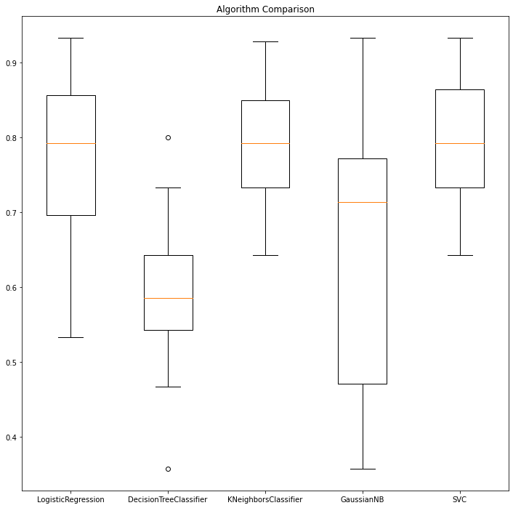
From the above image we can see that the KNeighbors and SVC are giving a good performance with low variance.
Let’s standardize the data using StandardScaler and see if that impacts the model performance.
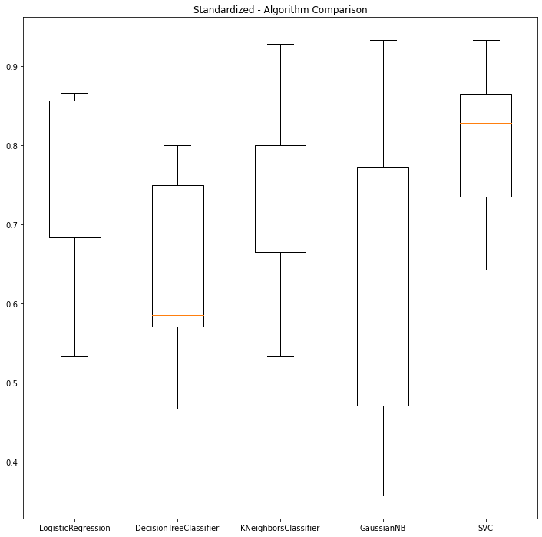
Notice that using StandardScaler has slightly impacted the SVC model’s performance positively. For code in github click here.

Ensemble Techniques:
Ensemble models are those models that create multiple weaker models and then combine them to produce better results. Let’s see if ensemble models are able to give a better performance than SVC. For code in github click here.
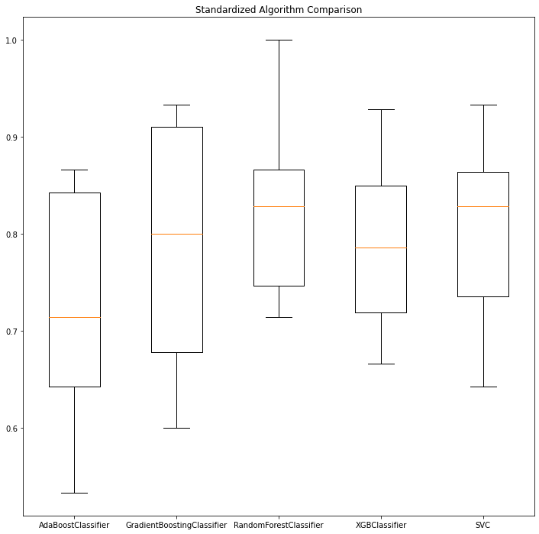
Results:
AdaBoostClassifier: Mean score: 0.724 Variance: 0.013
GradientBoostingClassifier: Mean Score: 0.78 Variance: 0.016
RandomForestClassifier: Mean Score: 0.827 Variance: 0.08
XGBClassifier: Mean Score: 0.788 Variance: 0.008
SVC: Mean Score: 0.807 Variance: 0.009
From the above image, we can see that RandomForestClassifier is giving a performance slightly better than SVC. I will further tune both the SVC and the RandomForestClassifier models to see if I can extract their best performances for this dataset.
Hyperparameter Tuning:
A hyperparameter of a model is a parameter whose values is used to control the learning process of the Machine Learning model. (Ref: Wiki).
These hyperparameters play a vital role in how the model/algorithm learns the patterns/functions in a dataset. They directly control the behaviour of the model and have significant influence on the model performance. Hence tuning the hyperparameters in a way that it learns the most out of the dataset is important for us.
However, there is a caveat. Most of the times we will run into the overfitting or underfitting problems when we do hyperparameter tuning. To avoid it is a general practice to use a cross validation technique while tuning the hyperparameters.
Cross validation is a technique in which we take different samples of train and test data from the dataset and test the model’s performance for each sample. The hyperparameters that gives the best performance on average in cross validation is the best configuration for the model indicating low bias and low variance (i.e., it avoids underfitting and overfitting).
For the cross validation and hyperparameter tuning, I choose the GridSerachCV class from the sklearn library. The GridSearchCV does an exhaustive search over all the specified parameter values for an estimator. For code, visit Github.
The Best score for SVC : 0.8480952380952381 with parameters: {'C': 0.9, 'gamma': 'auto', 'kernel': 'poly'}
The Best score for RandomForestClassifier : 0.8419047619047619 with parameters: {'criterion': 'entropy', 'max_depth': 29, 'max_features': 'auto', 'n_estimators': 1050}

Observations:
The SVC is showing a slightly better performance. Also SVC is a simple model and RandomForestClassifier is a complex model. Hence, I am choosing SVC model over RandomForest for solving this problem.
The final model is: SVC(C= 0.9, gamma= 'auto', kernel= 'poly')
Creating Pipelines:
By creating a pipeline, we can automate all the pre-processing steps. The Pipeline Class in sklearn library can be used to create a pipeline. The pipeline should contain the estimator as the last step. Before the estimator we can add any number of pre-processing/transformation steps. For code, visit Github.
We can train the pipeline with the train set and validate it using the test set.
Final Results:
Test accuracy score for SVC model is 0.873015873015873
The above accuracy scores show that the SVC model is performing really well. However, to know how well it is classifying the classes ‘Rock’ and ‘Mine’ individually, let’s look at the Confusion Matrix.
Confusion Matrix:
[[26 3]
[ 5 29]]

The confusion matrix shows that out of 29 samples for the class ‘Rock’, about 26 of those are correctly classified as rocks and 3 are falsely classified as Mines. Out of 34 samples for the class mine, 29 are correctly classified and 5 are falsely classified.
Let’s look at the Classification Report:

precision recall f1-score support

R 0.84 0.90 0.87 29
M 0.91 0.85 0.88 34

Accuracy 0.87 63
macro avg 0.87 0.87 0.87 63
weighted avg 0.88 0.87 0.87 63

We can see that we are getting a better F1 score for Mines than Rocks. Which means the trade-off between Precision and recall is better in case of Mines.
Saving the Model pipeline for Productionizing:
Once the model pipeline is created and trained on the training dataset, in order to deploy the model in production or in any other environment, we need to serialize the model. To use the model, we can de-serialize the serialized model object and then make predictions. There are a few methods to serialize and de-serialize the model. I will be using the joblib library in this project. For code, visit Github.
Conclusion:
- In this problem, it is very critical to classify the 'Mines' correctly even if the model makes some mistake in classifying 'Rocks'. Because more than classifying a Rock as a Mine, if our model classifies Mines as Rocks, it could jeopardize peoples’ life.
- Based on the F1 score in the Classification Report above, the SVC model is doing a better job in precision-recall trade-off for Mines and is also doing a good job at classifying Rocks as Rocks. Hence, we have a good model for production.

